Name: _________________
Tutor Group: _____________
Year 6 to Year 7
Transition Workbook
sparxmaths.com
In this booklet, there are a range of questions from key topics that you will have seen in year 6 and will be helpful for the start of year 7.
Each topic has three sections:
- Introduce questions are warm-up questions to practise the basics.
- Strengthen questions build your knowledge in key concepts.
- Deepen questions are more challenging reasoning and problem-solving questions.
Use the grid below to keep track of your progress in each topic. Tick the sections you have attempted.
Introduce Strengthen Deepen Teacher comment
Place value
Negative numbers
Rounding
Adding
Subtracting
Multiplying
Dividing
Fractions 1
Fractions 2
Factors and prime numbers
Area and perimeter
Ratio relationships
Q2
Q3
Q4
Write
four hundred and six
in figures.
Write down these numbers in order of size, starting with the smallest:
,
3.8
,
3.6
,
3.9
,
3.5
3.4
In which
two
of these numbers does the digit 7 have a value of 0.7?
Which one of these numbers has 4 tens?
543
,
,
534
,
435
4563
Answer:
Answer:
Answer:
Answer:
and
Introduce
57.2
23.71
64.17
79.24
17.56
14.78

Q2
Q3
Q4
Arrange these numbers in ascending order (from smallest to largest):
,
4.46
9,
,
8.8
1.5,
6.06
,
4.21
Which of these numbers is closest to 1?
Arrange the number cards in the place value grid to make the
largest
possible
number.
Which of these numbers shows
five thousand and eight
?
Answer:
Answer:
Answer:
Ones
1
Tenths
1
10
Hundreths
1
100
Answer:
58
508
500,008
50,008
5008
0.9404
0.907
0.94
0.9005
0.9306
0.9408
3
5
9
.
Strengthen
Q2
Q3
Q4
Write down the number
two million and thirty
in figures.
Using these cards, what is the
closest number
to 320 that you can make?
You must use
all
the cards and use each card only
once
.
Arrange all three number cards below to create the largest
even
three-digit number.
Work out the number that should go in the box to complete the sum.
8000 +
5
+
= 8065
Answer:
Answer:
Answer:
Deepen
5
2
7
3
.
5
8
7
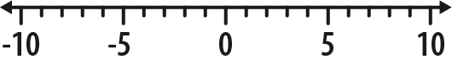
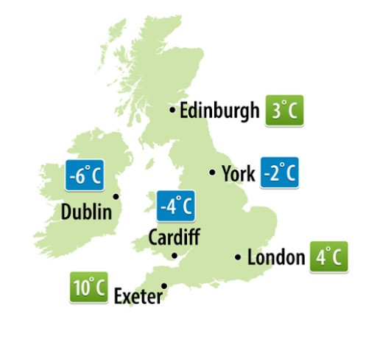
Q2
Q3
Q4
What number is the arrow pointing to on this scale?
The weather map shows the temperature recorded one night last winter.
Which city had the
lowest
temperature?
Which is higher,
a)
-4
or 1?

b)
or -2?
-6
What numbers should replace A, B, C and D on the number line?
Answer:
A:
B:
C:
D:
Answer:
Answer:
Answer:
_{a)}
b)
-5
-3
-1
0
A
B
C
D
4
3
5
-10
0
Introduce

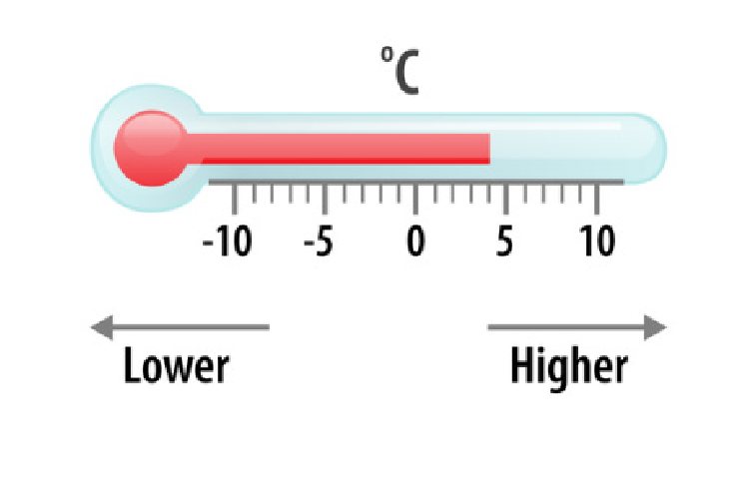
Q2
Q3
Q4
Q5
Write these temperatures in order, starting with the coldest:
9
ºC, -8ºC, 3ºC, -10ºC, 0ºC, 7ºC
Write these numbers in ascending order (lowest to highest).
77
,
-17, -770, 700, 7, 70
Write < or > in the empty boxes below to make the statements correct.
Write down these numbers in ascending order (lowest to highest).
-2
2.1
, -4.5, 4.3, -4.2, -2.5,
Find the temperature that is 9ºC lower than 4ºC.
Answer:
ºC
Answer:
Answer:
Answer:
-
6
-
2
3
-
4
-
8
-
7
Strengthen
Q2
Q3
Q4
Put the number cards shown below in the gaps to make the
lowest
number possible.
The decimal point should have numbers on both sides, and each card should be used
only once.
Using each of the cards below only once, what is the closest number to -64.28 that you
can make?
Ethan is thinking of a negative number that is lower than -4 and higher than -10.
His number is odd and a multiple of 3
What number is he thinking of?
Put the number cards shown below in the gaps to make the
lowest
number possible.
Use each card once.
-
-
-
3
6
5
8
7
2
3
.
8
3
7
9
.
5
Deepen
Q2
Q3
Q4
Q5
What is 63 rounded to the nearest 10?
What is 720 rounded to the nearest 100?
Round 350 to the nearest 100
What is 12.5 rounded to the nearest whole number?
What is 5.47 rounded to the nearest whole number?
Answer:
Answer:
Answer:
Answer:
Introduce

Q2
Q3
Q4
Q5
Rounding to the nearest ten, which two numbers round to 40?
A pair of jeans costs £21.62
What is the cost of the jeans to the nearest £1?
What is 5279 rounded to the nearest 100?
When rounded to the nearest 1000, which
two
of these numbers round to 8000?
What is 990 rounded to the nearest 100?
Answer: £
Answer:
Answer:
Answer:
and
and
46
33
41
39
48
7496
7528
7216
8572
8312
8763
Strengthen
Q2
Q3
Q4
A school raises £1876
The local newspaper writes that they raised £1900
Complete the sentence shown below.
Tim thinks of a whole number.
Rounded to the nearest 10, his number is 20
List all the possible numbers Tim could be thinking of.
A piece of string is 14 cm long, to the nearest centimetre.
What is the
smallest
possible length of the piece of string?
The number of people in a stadium is 47,000 when rounded to the nearest 1000
people.
What is the minimum number of people that could be in the stadium?
Answer:
Answer:
cm
The newspaper has rounded to the nearest
Deepen
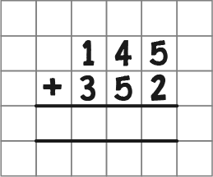
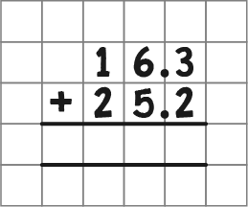
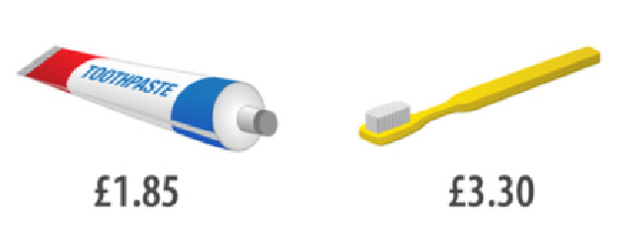
Q2
Q3
Q4
Q5
Complete the calculation to work out 145 + 352
Complete the calculation to work out 16.3 + 25.2
Use the prices below to work out the total cost of
two
erasers and
one
pencil.
Ruler

30
p
Pencil

p
25
Blue pen

p
35
Green pen
p
40
Eraser

20
p
What is the total cost of a tube of toothpaste and a toothbrush?
Add together 1750 and 281
Answer:
Answer:
Answer:
p
Answer: £
Introduce

Q2
Q3
Q4
Work out 135 + 17 + 133
Work out 18.2 + 34.1 + 13.5
Work out 15.6 + 8.76
Calculate 17468 + 2606
Answer:
Answer:
Answer:
Strengthen
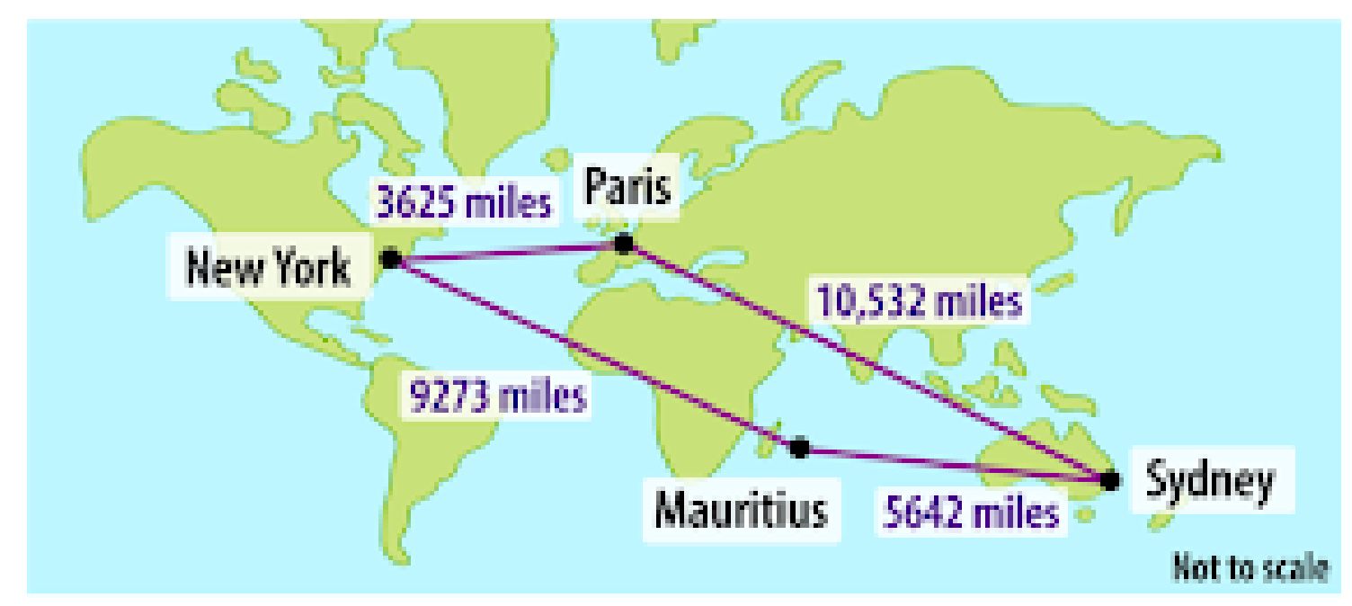
Q2
Q3
Fill in the gaps below to complete the calculation.
In one week, a pilot flew from Paris to Sydney, from Sydney to Mauritius, from
Mauritius to New York, then back to Paris from New York.
How many miles did he fly in total?
Add together the four numbers below.
, 38, 9.78,
6.8
27.49
Answer:

6

2

2

8
1

9
1
+
Paris
3625
miles
10
,532 miles
9273
miles
miles
5642
New York
Mauritius
Sydney
Deepen
Q2
 | Introduce
Complete the calculation below to work out 847 - 215  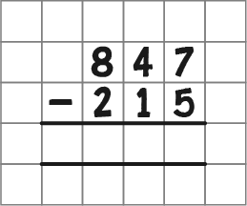 | Answer:
Work out 3784 - 313 | Answer:
Work out 646 - 271 | Answer:
Work out 35.6 - 12.5 | Answer:
Work out 56.4 - 13.7
Q3
Q4
Q5

Q2
Q3
Q4
Q5
Rob has £154. He spends £82 on a new coat.
How much money does Rob have left?
Tyler went to the shop with £8.30. He spent £4.60
How much did he come home with?
Subtract 1549 from 1637
Subtract 3.5 from 13.3
Work out 2361.4 - 84.9
Answer: £
Answer: £
Answer:
Answer:
Strengthen
Q2
Q3
Q4
Add 238 to 567, then subtract 132
What is the answer?
Grace is 1.45 m tall.
Jackson is 0.2 m shorter than Grace.
How tall is Jackson?
Fill in the gap below to complete the calculation.
Jack has 14.4 m of rope.
Amy cuts off 2.68 m.
How much rope is Jack left with?
Answer:
m
m
Answer:
8
7
5
1
8
5
-
5

3

Deepen
Q2
Q3
Q4
Q5
Work out 720 x 10
Work out 56 x 100
Work out 17 x 3
Work out 26 x 7
Multiply 284 by 5
Answer:
Answer:
Answer:
Answer:
Introduce

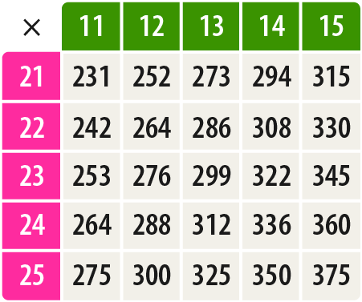
Q2
Q3
Q4
Use the multiplication table below to calculate 22 x 14
Work out 36 x 21
Work out 17 x 503
One table costs £63
How much would 502 tables cost?
Answer:
Answer:
Answer:
Answer: £
Strengthen
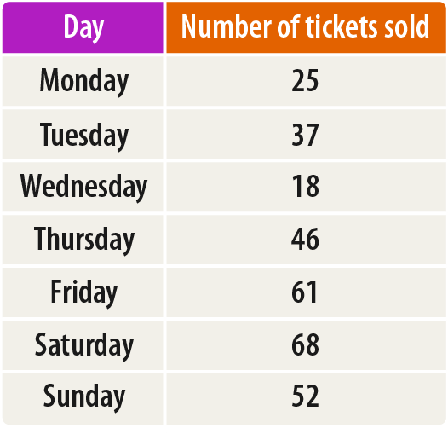
Q2
Q3
In the multiplication triangle below, the numbers in the circles multiply together to
make the number in the rectangle in between.
Fill in the gap.
In the number pyramid below, each number is calculated by multiplying the two
numbers below it.
Find the missing numbers in the number pyramid.
A plane ticket to Vienna costs £194
This table shows the number of plane tickets to Vienna sold each day last week.
How much money was spent on tickets to Vienna on Tuesday?
Answer: £
1
44
1824
5244
4
4
36
24
69
76
Deepen
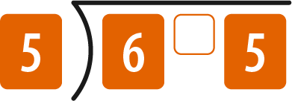
Q2
Q3
Q4
Q5
Q6
Work out 720 ÷ 10
What is 64.1 ÷ 10?
I have 21 coins and want to arrange them into 3
equal
groups.
How many coins will be in each group?
What is the
remainder
when 23 is divided by 4?
Work out 65 ÷ 5
Divide 170 by 5
Answer:
Answer:
Answer:
Answer:
Answer:
Introduce

Q2
Q3
Q4
Q5
Work out the number that should go in the box to complete the calculation.
Divide 312 by 6
Divide 266 by 7
Anne has £144 to share between her 6 grandchildren for Christmas.
If she divides the amount equally between them, how much does each grandchild
receive?
Calculate 288 ÷ 12
Answer:
Answer:
Answer: £
÷ 10 = 0.3
Strengthen
Q2
Q3
Q4
A group of 4 friends has a bag of 47 sweets.
They divide the sweets equally between them.
a)
How many sweets does each friend receive?
b)
How many sweets are left over?
Bruce needs 26 burgers for a barbecue.
They are sold in packs of 6
How many packs does he need to buy?
Look at the two calculations below.
Use the top calculation to find the missing number in the calculation below it.
777
will divide by 37 with no remainder.
What is the remainder when 775 is divided by 37?
Answer:
=

50
300
÷ 12 =
25
300
÷

Answer:
_{a)}
b)
Deepen
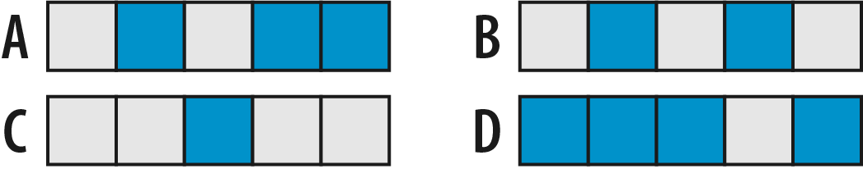
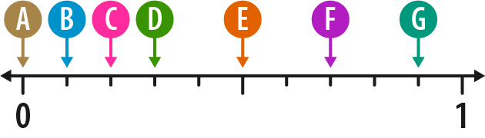
The number line below is divided into 10 equal parts.
Which letter shows the position of ?
Q2
Q3
Q4
Which shape below is shaded?
2
5
3
10
What fraction of this shape is shaded?
What is
two out of eleven
written as a fraction?
Answer:
Answer:
Answer:
Introduce

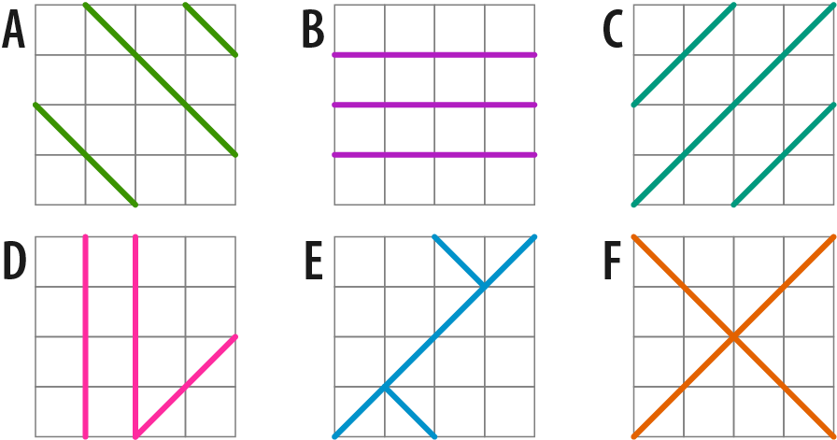
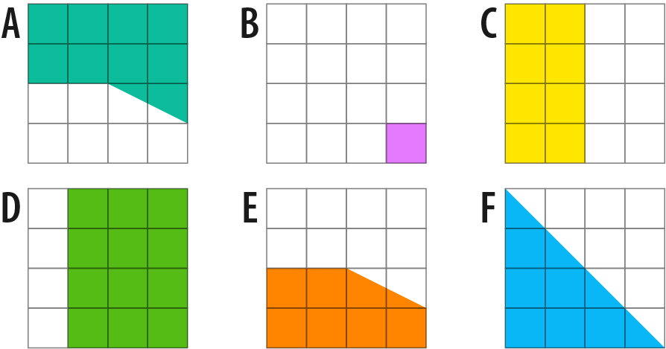
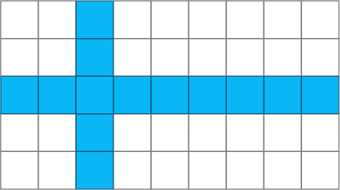
Answer:
Q2
Q3
Which
two
of the shapes are
half shaded
?
What fraction of the flag shown below is shaded?
Write down the
two
shapes that are divided into
quarters
.
Answer:
and
and
Strengthen
Q2
 | Deepen
Write down the two shapes are less than half shaded.  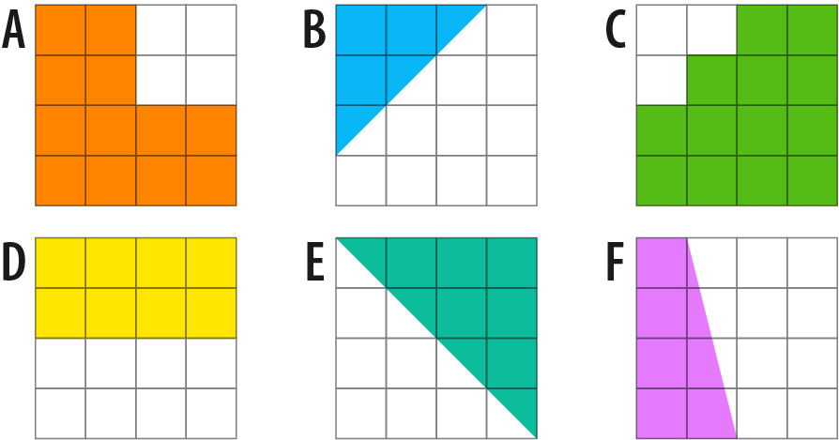 | Answer: and
What fraction of £1 is 17p? | Answer:
What fraction of an hour is 23 minutes? | Answer:
Which two of the shapes below are shaded?  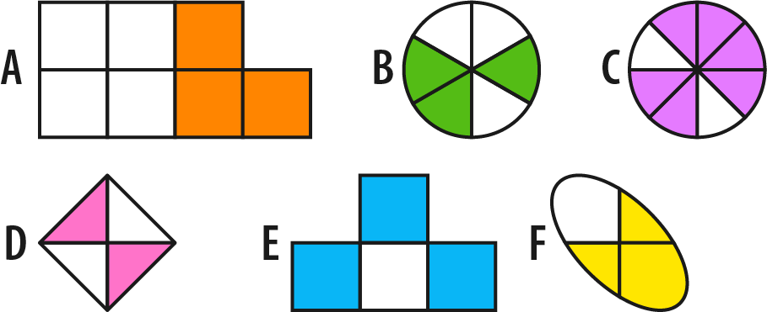 | and
Q3
Q4
2
5
Q2
Q3
What is the missing number in these equivalent fractions?
Simplify
What fraction of the shape below is shaded?
Give your answer in its simplest form.
2
10
20
=
Answer:
Answer:
Answer:
Q4
Put these fractions into ascending order (smallest to largest):
7
10
,
,
2
10
3
10
Introduce

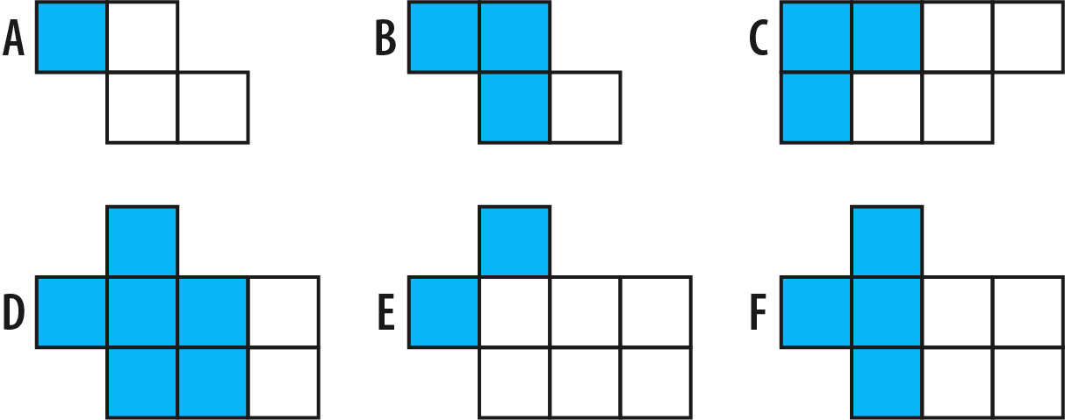
Put these fractions into ascending order (smallest to largest):
,
,
3
4
1
4
5
8
Q2
Q3
Q4
Which
two
shapes are shaded?
Use two of the cards below to make a fraction that is equivalent to
Complete this equality to find the three equivalent fractions.
Answer:
and
3
4
16
20
1
4
16
20
3
20
=
=
=
1
2
4
5
10
16
Strengthen
Answer:
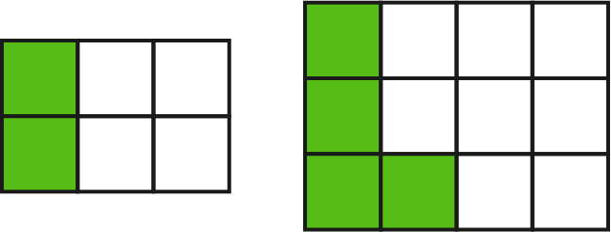
Q2
Q3
Hamza makes a cake and cuts it into 16 equally sized pieces.
He gives 12 pieces to Jack.
What fraction of the cake does Hamza have left?
Give your answer in its
simplest form
.
Jan says that the same fraction of each rectangle below has been shaded.
Is Jan correct?
Write a sentence to explain your answer.
What fraction is exactly halfway between and ?
Answer:
4
5
14
15
Answer:
Answer:
Deepen
For each number, decide whether it is prime or not prime:
5
a)
1
b)
8
c)
Q2
Q3
Q4
Q5
Q6
Work out all the factors of 10 by completing the factor pairs below.
Work out
all
the factors of 14
Which two numbers complete the following sentence?
Find
all
of the prime numbers from the list:
,
11
,
18
,
1
,
17
,
21
14
Write out
all
of the prime numbers between 0 and 10
Answer:
Answer:
Answer:
x
x
10

=
is a prime number because it only has two distinct factors, which are
7
and

10
=
Answer:
a)
b)
c)
Introduce

Q2
Q3
Q4
Which number in the list below is
not
prime?
13
,
15
,
19
,
17

11
Find
all
the factors of 20
Which
three
of the numbers below are factors of 100?
,
2
,
9
10
,
25
35
,
200
,
How many factors does 40 have?
Answer:
Answer:
Answer:
,
Answer:
and
Strengthen
Q2
Q3
For each number, decide whether it is prime or not prime:
a)
51
b)
87
c)
59
What is the largest two-digit prime number?
Find two primes which add to make 28
What is the difference of these two primes?
Answer:
Answer:
Answer:
a)
b)
c)
Deepen
Q2
 | Introduce
What is the area of this rectangle?  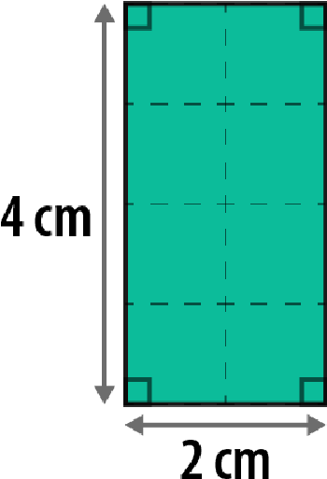 | Answer: | cm²
What is the perimeter of this triangle?  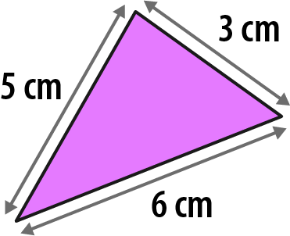 | Answer: | cm
What is the area of this rectangle?  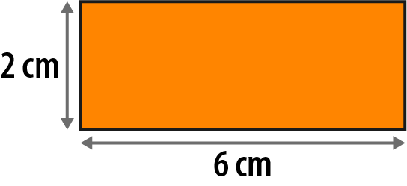 | Answer: | cm²
What is the perimeter of this rectangle?  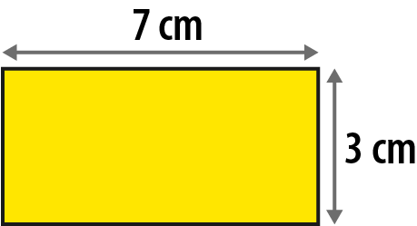 | Answer: | cm
Q3
Q4

Q2
 | Strengthen
What is the area of this rectangle?  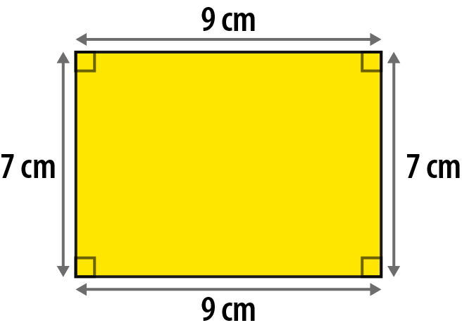 | Answer: | cm²
Work out the area and perimeter of this rectangle.  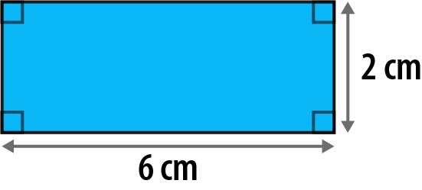 | Perimeter:  Area: | cm² cm
What is the area of this square?  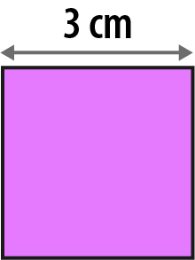 | Answer: | cm²
Calculate the perimeter of this regular pentagon.  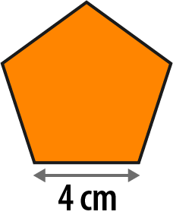 | Answer: | cm
Q3
Q4
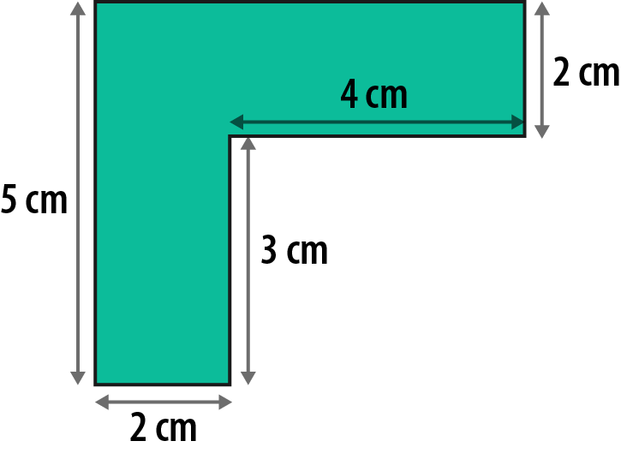
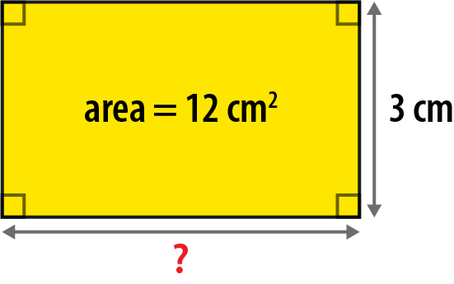
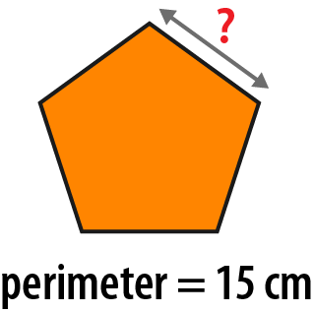
Q2
Q3
Q4
Work out the
perimeter
of this shape.
What is the length of the unknown side in this rectangle?
What is the length of one side of this regular pentagon?
A rectangle has an
area
of 24 cm
²
.
How long could the sides of the rectangle be?
Give three different examples.
Answer:
Answer:
Answer:
Answer:
cm
cm
cm
Deepen
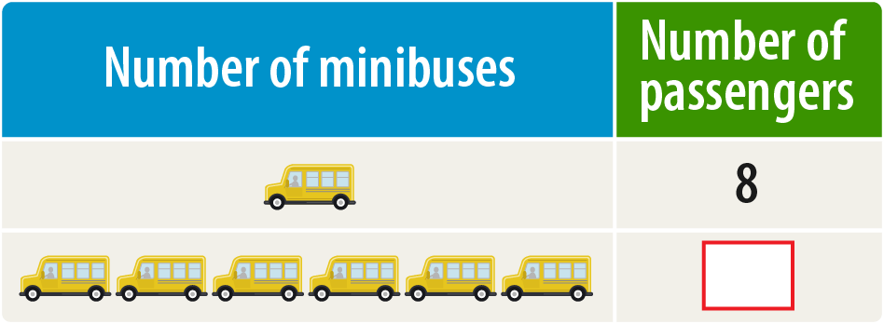
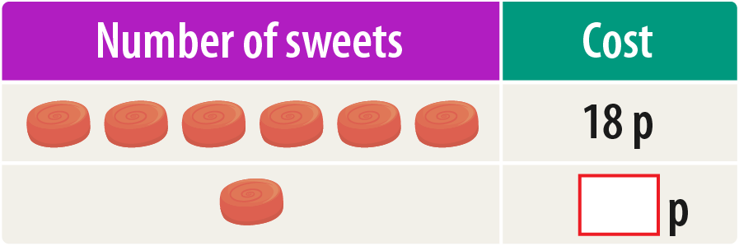
Q2
Q3
1
minibus can seat 8 passengers.
How any passengers can be seated on 6 identical minibuses?
A recipe to serve 4 people uses 200g of flour.
How much flour is needed to make the same recipe to serve 8 people?
Asher buys 6 identical sweets that cost 18p in total.
How much does 1 of the sweets cost?
Answer:
g
p
Introduce

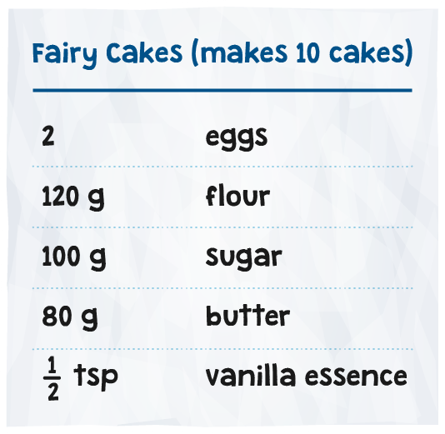
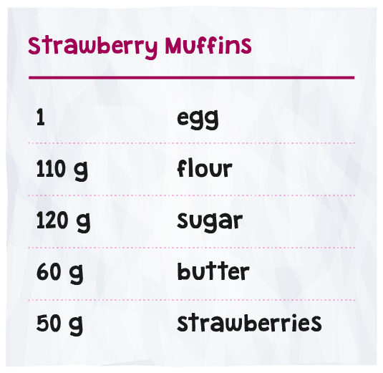
Q2
Q3
Imran is making fairy cakes using the recipe below.
How much flour is needed to make 20 fairy cakes?
Johanna is baking chocolate biscuits.
The recipe she is following uses 150g of sugar and makes 30 biscuits.
If Johanna only has 50g of sugar then how many of these biscuits can she make?
Indie makes some strawberry muffins following the recipe provided.
If Indie uses 550g of flour, how many grams (g) of strawberries must she use?
Answer:
Answer:
Answer:
g
g
Strengthen
Q2
Q3
Alice buys 10 identical toy boats and spends £80 in total.
How much would 7 toy boats cost?
Finn is stacking identical cube-shaped boxes.
He stacks 7 boxes to make a tower that is 112cm tall.
He adds 1 more box to the tower.
How tall is the tower now?
Mia wants to predict how many times her heart will beat in an hour.
When she is resting, her heart beats 5 times in 6 seconds.
a)
Use this information to predict the number of times her heart will beat in 1 minute.
b)
Predict the number of times her heart will beat in 1 hour.
Answer: £
Answer:
cm
Answer: a)
Answer: b)
Deepen

