Emily Brett-Greenacre
Leader of English
Evaluating the text…
Q4 = To what extent do you agree? (20 marks)
English language
Paper 1, Question 4
ENGAGE #1: think, pair and share…
- What ‘’T’ means to walk slowly and with heavy steps?
- What ‘S’ means the cut stalks of plants sticking out of the ground after harvesting?
- What ‘U’ means a dense patch of shrubs and plants?
- What ‘P’ is a type of plastic?
- What ‘S’ means to shake and tremble from the cold?
- What ‘H’ means to pause because you are unsure?
- What ‘S’ means to almost fall over?
- What ‘T’ means to be walking on with purpose and intent?
ENGAGE #2: blockbuster quiz…
Evaluate
‘King of the Castle’ by Susan Hill
This extract is from the end of a novel by Susan Hill, it was first published in 1970. It tells the story of two warring boys: Edmund Hooper and Charles Kingshaw, who have been forced together due to their parents’ relationship and impending marriage. In this section, Kingshaw feels that he has lost everything, including his friends and his mother, to Hooper.

The moment he came awake, it was just dawn, and he remembered, and then he knew, quite suddenly, what to do. It was because the morning reminded him of the time before. The house was quiet. When he looked out of his window, it was clear and grey.
The open suitcases seemed to have nothing to do with him, now.
Outside, it was cool and the air felt moist, though it had stopped raining and the wind had dropped. But once he had climbed over the fence and begun to trudge up the first field, the grass was thick and wet. The only difference today was that there was no mist, he could see a long way ahead, the sky was smooth and pale.
They had cut the corn, and burned the stubble, and the field seemed much bigger, the trees on the edge of the wood looked a long distance away. The outer edges were fringed with yellow and brown, but inside, it was dark green and thick, the leaves hadn’t started to fall.
At first, when he stepped inside the wood, he stood still. He was not certain of the way, now, beyond the first bit. They had turned and changed direction so much, after following the deer. He tried to remember the way the men had brought them, when they came out again.
The smell was familiar, the one he had smelled when he crawled out from under the bush, after the thunderstorm, fresh and cool, but sweet-rotten, too, from the soil and the leaf-mould.
He felt suddenly excited. This was his place, it was where he wanted to be. It was all right. He said to himself, again and again this is all right. He began to push his way slowly through the damp undergrowth.
At Warings, Hooper slept, flat on his belly, his mind blank, but on the floor below, his father moved and tossed, excited by dreams. Waking, Mrs Helena Kingshaw thought, it is today, and this is the best thing that could have happened, the best thing for both of us. I shall not be a struggling, lonely woman now, that is all past, all done with and forgotten, and we are going to be happy, all of us together. Everything is about to begin.
She got out of bed and looked at the oval travelling alarm clock. On the wardrobe door, the cream-coloured linen suit hung, showing palely through its polythene. Mrs Kingshaw thought, there is plenty of time for everything, plenty of time. And sat down on the edge of her bed again, to smoke a cigarette. It was a little after seven o’clock.
Kingshaw had found the clearing now. The stones were still there, piled up, from when they had built the fire. It seemed a long time ago. He didn’t stop to look.
On the bank of the stream, he took all his clothes off, and folded them in a pile. He shivered and the water was very cold, silky, against his body. For a second, he hesitated, part of his mind starting to come awake. And then he thought of everything, of what else would happen, he thought of the things Hooper had done and what he was going to do, of the new school and the wedding of his mother. He began to splash and stumble forwards, into the middle of the stream, where the water was deepest. When it had reached up to his thighs, he lay down slowly and put his face full into it and breathed in a long, careful breath.
It was Hooper who found him, because he had known at once where he would have gone, they all followed Hooper, trampling and calling. The rain had begun again, dripping down on their heads and shoulders through the dark leaves.
When he saw Kingshaw’s body, upside down in the water, Hooper thought suddenly, it was because of me, I did that, it was because of me, and a spurt of triumph went through him.
‘Now, it’s all right, Edmund dear, everything is all right,’ Mrs Helena Kingshaw put an arm out towards him, held him to her. ‘I don’t want you to look, dear, you mustn’t look and be upset, everything is all right.’
Hooper felt the damp cloth of her coat, pressed against his face, and smelled her perfumy smell. Then, there was the sound of men, splashing through the water.

WHO: (does the extract focus on)?
WHERE: (does the extract take place – setting)?
WHEN: (time period, time of year or day)?
WHAT:
(beginning…
Middle…
End…)?
WHY: (effect on reader, deeper meaning or message)?

EXPLORE: double check you understand the question before you respond
Focus this part of your answer on the second half of the Source from line 20 to the end.

A student said: ‘I like how the writer allows us to experience the events from different characters’ perspectives.’

To what extent do you agree? [20 marks]

Level 3 – A clear, relevant evaluation.  11-15 marks | - Clearly and consistently responds to the statement.  - Supports ideas with a range of short, relevant quotations.  - Clearly explains the writer’s methods – words, phrases and techniques to justify how much they agree with the statement and how effective the writer is.
Level 2 – Some evaluation.  6-10 marks. | - Make clear comments in response to the statement.  - Supports ideas with appropriate textual references (quotes).  - Comment on the writer’s use of methods – words, phrases and techniques to justify how much they agree with the statement.
EXPLORE: the GCSE mark scheme – what is the examiner looking for...?

A
The writer brings the characters alive by making them behave and react differently so that we form an opinion about each character on the coach. For example, the ‘old fellow’ loses his temper with the driver but makes things worse for everybody by opening the window and ‘brining a shower of rain on himself and his fellow-passengers’. This effectively amuses the reader because the old man’s anger makes him foolish. We view his cursing at the driver as pointless because it does nothing to change the situation and the reader knows the driver is just doing his best. The writer views the old man as foolish because his excessive use of violent words like ‘rogue’ and ‘murderer’ make him seem unreasonable.

The writer brings the characters alive by making them different to each other – each character on the coach has their own personality, which makes them individual like real people in real life. The ‘old fellow’ makes us laugh because he is so angry that he is ‘fumbling’ with the window sash and so gets everybody wet. This seems pointless and silly. The writer makes us understand that this passenger is grumpy, which is different to the other characters on the bus. We know he is grumpy because the writer tells us that he had ‘kept up a constant complaint ever since he joined the coach.’ This shows he is grumpy and in a bad mood. It proves he is moaning and is unhappy.
B

I fully / partially agree that … ____________________________
APPLY: respond to the question…
_____________________________________________________________________________________________________________________________________________________________________________________________________________________________________________________________________________________________________________________________________________________________________________________________________________________________________________________________________________________________________________________________________________________________________________________________________________________________________________________________________________________________________________________________________________________________________________________________________________________________________________________________________________________________________________________________________________________________________________________________________________________________________________________________________________________________________________________________________________________________________________________________________________________________________________________________________________________________________________________________________________________________________________________________________________________________________________________________________________________________________________________________________________________________________________________________________________________________________________________________________________________________________________________________________________________________________________________________________________________________________________________________________________________________________________________________________________________________________________________________________________________________________________________________________________________________________________________________________________________________________________________________________________________________________________________________________________________________________________________________________________________________________________________________________________________________________________________________________________________________________________________________________________________________________________________________________________________________________________________________________________________________________________________________________________________________________________________________________________________________________________________________________________________________________________________________________________________________________________________________________________________________________________________________________________________________________________________________________________________________________________________________________________________________________________________________________________________________________________________________________________________________________________________________________________________________________________________________________________________________________________________________________________________________________________________________________________________________________________________________________________________________________________________________________________________________________________________________________________________________________________________________________________________________________________________________________________________________________________________________________________________________________________________________________________________________________________________________________________________________________________________________________________________________________________________________________________________________________________________________________________________________________________________________________________________________________________________________________________________________________________________________________________________________________________________________________________________________________________________________________________________________________________________________________________________________________________________________________________________________________________________________________________________________________________________________________________________________________________________________________________________________________________
REFLECT: self/peer-assess and summarise…
- Some appropriate comments with supporting quotations
- Some identification of writer’s use of methods and the effects.
- Clear, consistent comments in response to the question with supporting quotations.
- Clear explanation of writer’s methods and the effects.
- Clear analysis of writer’s methods and the effects.
- Specific comments in relation to the question with short, supporting quotations.
- Specific analysis of writer’s methods and the effects.
- Detailed, concise comments with short, embedded quotes.
- Analyses and interprets writer’s methods and the effects.

PAPER 1, QUESTION 4
- What have you learnt today about this question that you didn’t know before?

- What advice or top tips would give for this question?

- What will you do differently next time you have to complete this question?

Extension Work / Revision to do at home:

- Read again the first part of the source, lines 1 – 8.
List four things from this part of the text about the weather that morning.
A. __________________________________________________________________________________
__________________________________________________________________________________
B.
__________________________________________________________________________________
C.
__________________________________________________________________________________
D.

[4 marks]

- Look in detail at this extract from lines 9 - 19 of the source:

They had cut the corn, and burned the stubble, and the field seemed much bigger, the trees on the edge of the wood looked a long distance away. The outer edges were fringed with yellow and brown, but inside, it was dark green and thick, the leaves hadn’t started to fall.

At first, when he stepped inside the wood, he stood still. He was not certain of the way, now, beyond the first bit. They had turned and changed direction so much, after following the deer. He tried to remember the way the men had brought them, when they came out again.

The smell was familiar, the one he had smelled when he crawled out from under the bush, after the thunderstorm, fresh and cool, but sweet-rotten, too, from the soil and the leaf-mould.

He felt suddenly excited. This was his place, it was where he wanted to be. It was all right. He said to himself, again and again this is all right. He began to push his way slowly through the damp undergrowth.

How does the writer use language here to describe the wood?
[8 marks]

- You now need to think about the whole of the source.
This text is from the ending of a novel.
How has the writer structured the text to interest you as a reader?
[8 marks]

Section B
- Your school or college is asking students to contribute some creative writing for its website.
Either: Write a description suggested by this picture
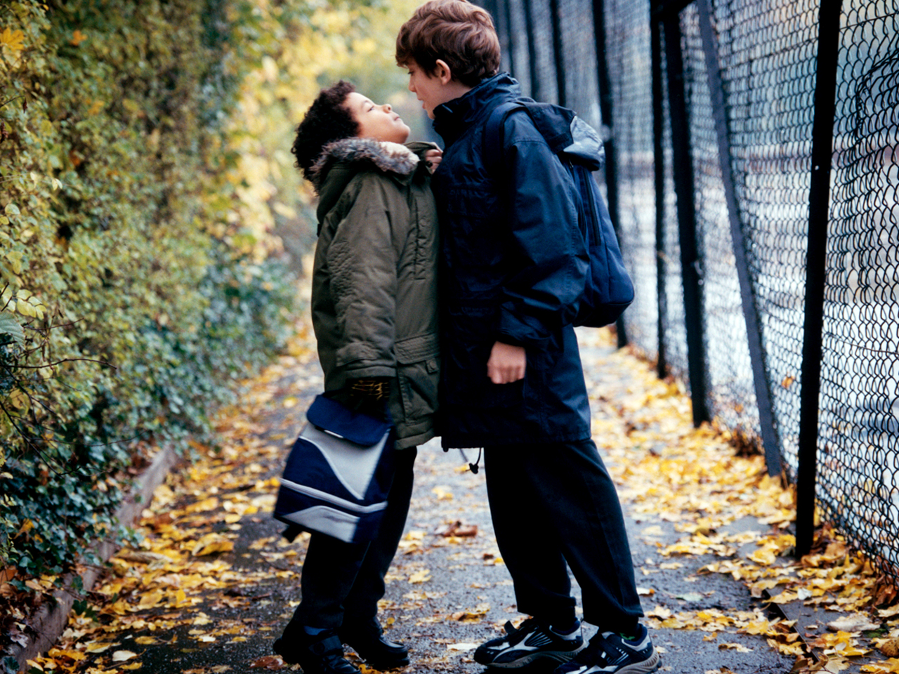

Or: Describe an occasion when you felt isolated or challenged. Focus on the thoughts and feelings you had at the time.
(24 marks for content and organisation)
(16 marks for technical accuracy)
[40 marks]

_____________________________________________________________________________________________________________________________________________________________________________________________________________________________________________________________________________________________________________________________________________________________________________________________________________________________________________________________________________________________________________________________________________________________________________________________________________________________________________________________________________________________________________________________________________________________________________________________________________________________________________________________________________________________________________________________________________________________________________________________________________________________________________________________________________________________________________________________________________________________________________________________________________________________________________________________________________________________________________________________________________________________________________________________________________________________________________________________________________________________________________________________________________________________________________________________________________________________________________________________________________________________________________________________________________________________________________________________________________________________________________________________________________________________________________________________________________________________________________________________________________________________________________________________________________________________________________________________________________________________________________________________________________________________________________________________________________________________________________________________________________________________________________________________________________________________________________________________________________________________________________________________________________________________________________________________________________________________________________________________________________________________________________________________________________________________________________________________________________________________________________________________________________________________________________________________________________________________________________________________________________________________________________________________________________________________________________________________________________________________________________________________________________________________________________________________________________________________________________________________________________________________________________________________________________________________________________________________________________________________________________________________________________________________________________________________________________________________________________________________________________________________________________________________________________________________________________________________________________________________________________________________________________________________________________________________________________________________________________________________________________________________________________________________________________________________________________________________________________________________________________________________________________________________________________________________________________________________________________________________________________________________________________________________________________________________________________________________________________________________________________________________________________________________________________________________________________________________________________________________________________________________________________________________________________________________________________________________________________________________________________________________________________________________________________________________________________________________________________________________________________________________________________
_____________________________________________________________________________________________________________________________________________________________________________________________________________________________________________________________________________________________________________________________________________________________________________________________________________________________________________________________________________________________________________________________________________________________________________________________________________________________________________________________________________________________________________________________________________________________________________________________________________________________________________________________________________________________________________________________________________________________________________________________________________________________________________________________________________________________________________________________________________________________________________________________________________________________________________________________________________________________________________________________________________________________________________________________________________________________________________________________________________________________________________________________________________________________________________________________________________________________________________________________________________________________________________________________________________________________________________________________________________________________________________________________________________________________________________________________________________________________________________________________________________________________________________________________________________________________________________________________________________________________________________________________________________________________________________________________________________________________________________________________________________________________________________________________________________________________________________________________________________________________________________________________________________________________________________________________________________________________________________________________________________________________________________________________________________________________________________________________________________________________________________________________________________________________________________________________________________________________________________________________________________________________________________________________________________________________________________________________________________________________________________________________________________________________________________________________________________________________________________________________________________________________________________________________________________________________________________________________________________________________________________________________________________________________________________________________________________________________________________________________________________________________________________________________________________________________________________________________________________________________________________________________________________________________________________________________________________________________________________________________________________________________________________________________________________________________________________________________________________________________________________________________________________________________________________________________________________________________________________________________________________________________________________________________________________________________________________________________________________________________________________________________________________________________________________________________________________________________________________________________________________________________________________________________________________________________________________________________________________________________________________________________________________________________________________________________________________________________________________________________________________________________________________
_____________________________________________________________________________________________________________________________________________________________________________________________________________________________________________________________________________________________________________________________________________________________________________________________________________________________________________________________________________________________________________________________________________________________________________________________________________________________________________________________________________________________________________________________________________________________________________________________________________________________________________________________________________________________________________________________________________________________________________________________________________________________________________________________________________________________________________________________________________________________________________________________________________________________________________________________________________________________________________________________________________________________________________________________________________________________________________________________________________________________________________________________________________________________________________________________________________________________________________________________________________________________________________________________________________________________________________________________________________________________________________________________________________________________________________________________________________________________________________________________________________________________________________________________________________________________________________________________________________________________________________________________________________________________________________________________________________________________________________________________________________________________________________________________________________________________________________________________________________________________________________________________________________________________________________________________________________________________________________________________________________________________________________________________________________________________________________________________________________________________________________________________________________________________________________________________________________________________________________________________________________________________________________________________________________________________________________________________________________________________________________________________________________________________________________________________________________________________________________________________________________________________________________________________________________________________________________________________________________________________________________________________________________________________________________________________________________________________________________________________________________________________________________________________________________________________________________________________________________________________________________________________________________________________________________________________________________________________________________________________________________________________________________________________________________________________________________________________________________________________________________________________________________________________________________________________________________________________________________________________________________________________________________________________________________________________________________________________________________________________________________________________________________________________________________________________________________________________________________________________________________________________________________________________________________________________________________________________________________________________________________________________________________________________________________________________________________________________________________________________________________________________________________
_____________________________________________________________________________________________________________________________________________________________________________________________________________________________________________________________________________________________________________________________________________________________________________________________________________________________________________________________________________________________________________________________________________________________________________________________________________________________________________________________________________________________________________________________________________________________________________________________________________________________________________________________________________________________________________________________________________________________________________________________________________________________________________________________________________________________________________________________________________________________________________________________________________________________________________________________________________________________________________________________________________________________________________________________________________________________________________________________________________________________________________________________________________________________________________________________________________________________________________________________________________________________________________________________________________________________________________________________________________________________________________________________________________________________________________________________________________________________________________________________________________________________________________________________________________________________________________________________________________________________________________________________________________________________________________________________________________________________________________________________________________________________________________________________________________________________________________________________________________________________________________________________________________________________________________________________________________________________________________________________________________________________________________________________________________________________________________________________________________________________________________________________________________________________________________________________________________________________________________________________________________________________________________________________________________________________________________________________________________________________________________________________________________________________________________________________________________________________________________________________________________________________________________________________________________________________________________________________________________________________________________________________________________________________________________________________________________________________________________________________________________________________________________________________________________________________________________________________________________________________________________________________________________________________________________________________________________________________________________________________________________________________________________________________________________________________________________________________________________________________________________________________________________________________________________________________________________________________________________________________________________________________________________________________________________________________________________________________________________________________________________________________________________________________________________________________________________________________________________________________________________________________________________________________________________________________________________________________________________________________________________________________________________________________________________________________________________________________________________________________________________________________________________
_____________________________________________________________________________________________________________________________________________________________________________________________________________________________________________________________________________________________________________________________________________________________________________________________________________________________________________________________________________________________________________________________________________________________________________________________________________________________________________________________________________________________________________________________________________________________________________________________________________________________________________________________________________________________________________________________________________________________________________________________________________________________________________________________________________________________________________________________________________________________________________________________________________________________________________________________________________________________________________________________________________________________________________________________________________________________________________________________________________________________________________________________________________________________________________________________________________________________________________________________________________________________________________________________________________________________________________________________________________________________________________________________________________________________________________________________________________________________________________________________________________________________________________________________________________________________________________________________________________________________________________________________________________________________________________________________________________________________________________________________________________________________________________________________________________________________________________________________________________________________________________________________________________________________________________________________________________________________________________________________________________________________________________________________________________________________________________________________________________________________________________________________________________________________________________________________________________________________________________________________________________________________________________________________________________________________________________________________________________________________________________________________________________________________________________________________________________________________________________________________________________________________________________________________________________________________________________________________________________________________________________________________________________________________________________________________________________________________________________________________________________________________________________________________________________________________________________________________________________________________________________________________________________________________________________________________________________________________________________________________________________________________________________________________________________________________________________________________________________________________________________________________________________________________________________________________________________________________________________________________________________________________________________________________________________________________________________________________________________________________________________________________________________________________________________________________________________________________________________________________________________________________________________________________________________________________________________________________________________________________________________________________________________________________________________________________________________________________________________________________________________________________________________
___________________________________________________________________________________________________________________________________________________________________________________________________________________________________________________________________________________________________________________________________________________________________________________________________________________________________________________________________________________________________________________________________________________________________________________________________________________________________________________________________________________________________________________________________________________________________________________________________________________________________________________________________________________________________________________________________________________________________________________________________________________________________________________________________________________________________________________________________________________________________________________________________________________________________________________________________________________________________________________________________________________________________________________________________________________________________________________________________________________________________________________________________________________________________________________________________________________________________________________________________________________________________________________________________________________________________________________________________________________________________________________________________________________________________________________________________________________________________________________________________________________________________________________________________________________________________________________________________________________________________________________________________________________________________________________________________________________________________________________________________________________________________________________________________________________________________________________________________________________________________________________________________________________________________________________________________________________________________________________________________________________________________________________________________________________________________________________________________________________________________________________________________________________________________________________________________________________________________________________________________________________________________________________________________________________________________________________________________________________________________________________________________________________________________________________________________________________________________________________________________________________________________________________________________________________________________________________________________________________________________________________________________________________________________________________________________________________________________________________________________________________________________________________________________________________________________________________________________________________________________________________________________________________________________________________________________________________________________________________________________________________________________________________________________________________________________________________________________________________________________________________________________________________________________________________________________________________________________

